A000-Bulgaria-Neolithic-Ceramic-Figurine-Female-VI Millennium BCE- Stara Zagora-91 mm

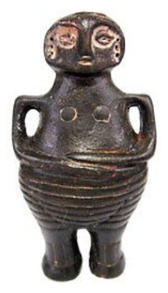 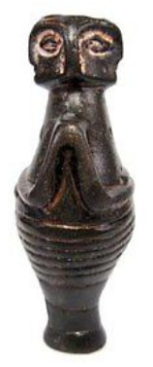 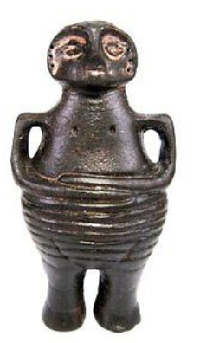 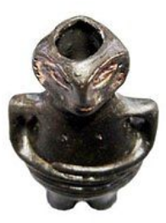

**Size-71/37 mm;                                     Weight-25 g;**